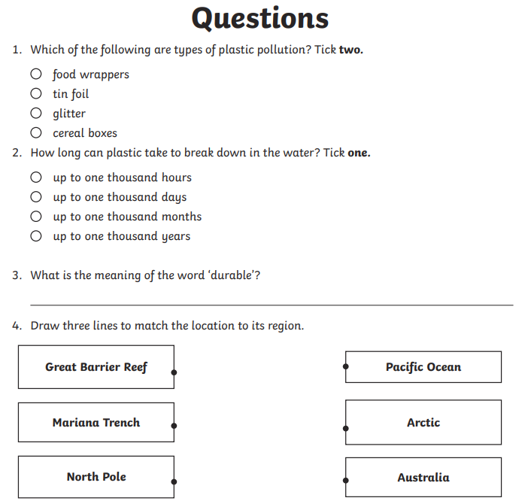
5. This is an information leaflet. From looking at the layout, how do you know this?
6. Is text a piece of fiction or non-fiction? Justify your answer.
7. Do you think that plastic pollution will improve in the future? What from the text makes you think this?

