Questions
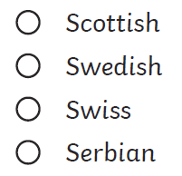
- Which nationality is Greta? Tick one:

- Which of Greta’s family members was an opera singer?
- What is the name of the movement Greta created?
- Look at the section called Greta’s Viewpoint. Find and copy one word which Greta uses to describe global warming.
- Write a definition of climate change in your own words.
- Why could Greta have been described as brave when she was only 15? Justify your answer.
- Predict what Greta might go on to do over the next ten years.

Questions
- Which nationality is Greta? Tick one:

- Which of Greta’s family members was an opera singer?
- What is the name of the movement Greta created?
- Look at the section called Greta’s Viewpoint. Find and copy one word which Greta uses to describe global warming.
- Write a definition of climate change in your own words.
- Why could Greta have been described as brave when she was only 15? Justify your answer.
- Predict what Greta might go on to do over the next ten years.

