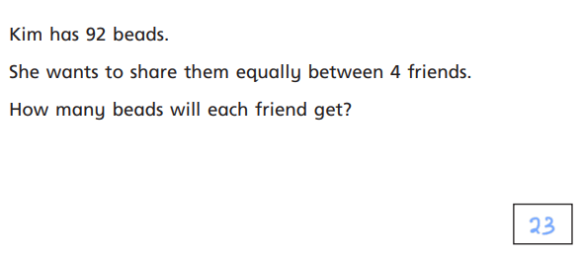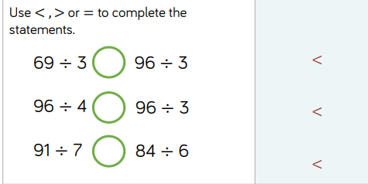
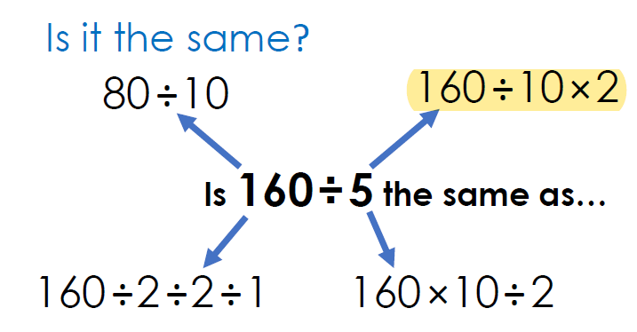

Explore: Left oval: 20, 100 Centre: 36 Right oval: 42 Outside: 46

Spot the Difference: Both calculations: 64 ÷4 = 16(a) is a grouping context (how many 4s in 64?)(b) is a sharing context (64 in 4 equal groups)

