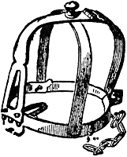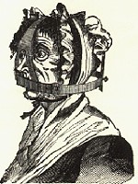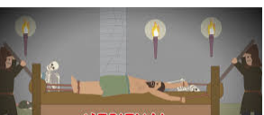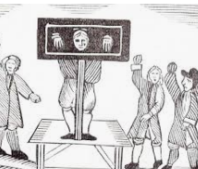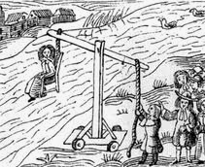

The brank was a punishment for on women who talked to much or spread rumours. It was a large iron framework placed on the head around the head forming a cage. There was a metal strip on the brank that fitted into the mouth and was either sharpened to a point or covered with spikes so that any movement of the tongue was caused severe injuries.

Accused witches (women) were dunked into a river in a ducking stool (a chair on a pole), to see if they were innocent or guilty. If they floated, they were considered guilty and burnt at the stake. If they sank, they were innocent but died anyway, by drowning. Either way, they died.

The **rack** was a rectangular, wooden frame, slightly raised from the ground, with a roller at one or both ends. The victim's ankles are fastened to one roller and the wrists are chained to the other. As the victim was interrogated, a handle was turned to stretch the victim causing excruciating pain.

The Brank (The gossip’s bridle)

The pillory was a T shaped block of wood with holes for the hands in the crossbar of the T. The person being punished would have to stand in the pillory in the middle of the market to be laughed at and have things thrown at them by passers-by. The sitting version with holes for the feet was called the stocks. holes for the feet T shaped block of wood with holes for the hands in the crossbar of the T. The person being punished would have to stand in the device in the middle of the market to be ridiculed by passersby.

The Ducking Stool

The Rack

The Pillory (standing)

The Stocks (sitting)

.