Teacher to mark

1. 800ml 2) 200ml 3) 1100ml

4) 7100ml 5) 2700ml 6) 8100ml

2)

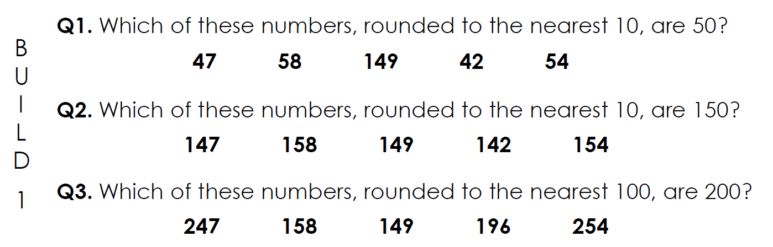

1)

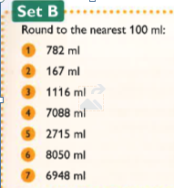

10

700

300

300

Teacher mark

4)

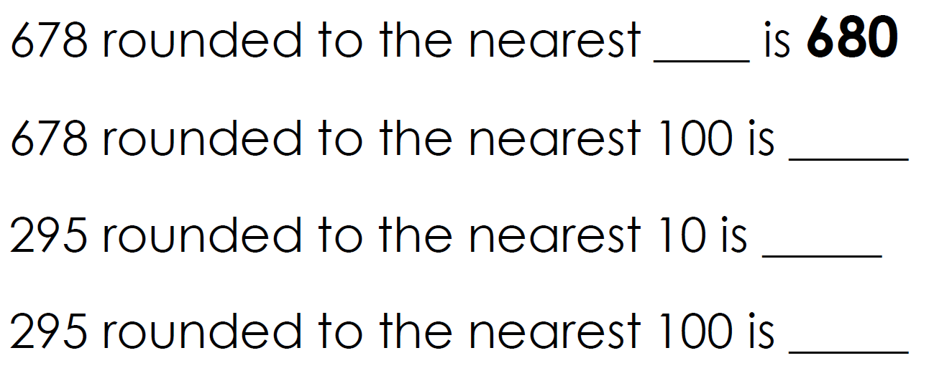

3)

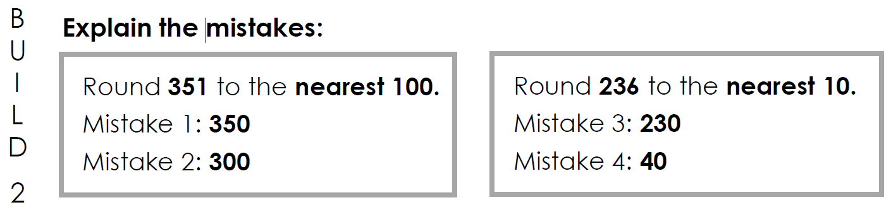

1. Always – 5,6,7,8,9 round up. You must look in the tens column to round to the nearest 100.
2. Never – you must look at the tens coloum to round to the nearest 100
3. Sometimes – if a number is 549 and below it rounds down, 550 and above rounds up. It is determined by the tens column.

Nearest 10 – 440, 350, 150, 150

Nearest 100 – 400, 400, 100, 200

6)

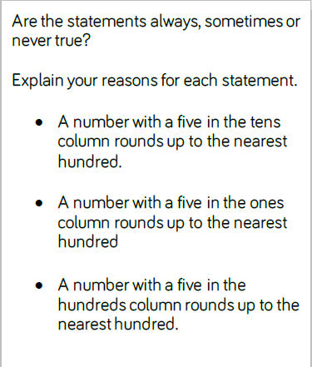

5)

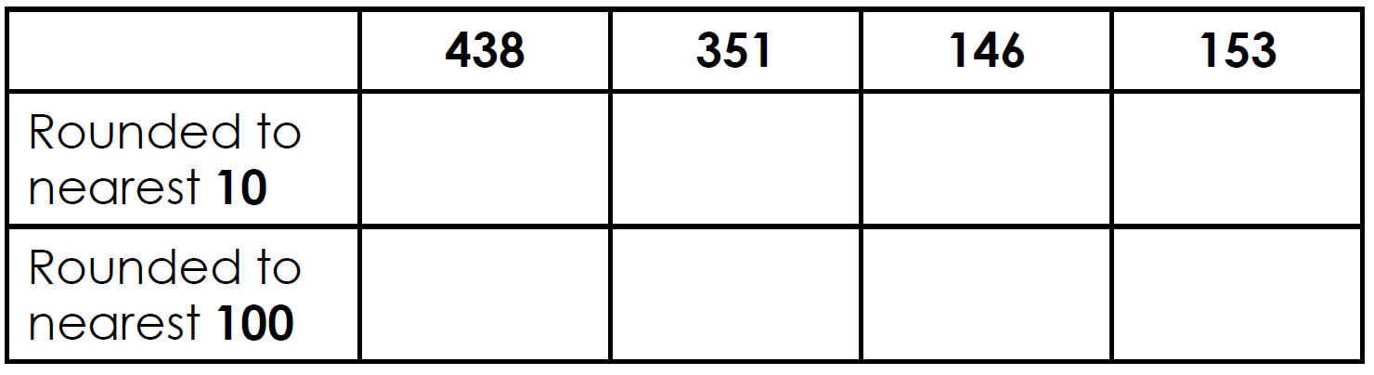

They round to the same hundreds because you must look at the tens column to determine the nearest 100. 5,6,7,8,9 round up and 1,2,3,4 round down.

They round to different tens because you must look at the ones column to work this out.

7)

