5900 - 6000

4500 - 4600

1000 - 2000

5)

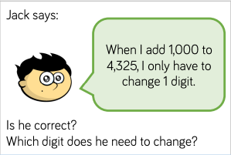

3) Find the previous and next multiple of each letter:

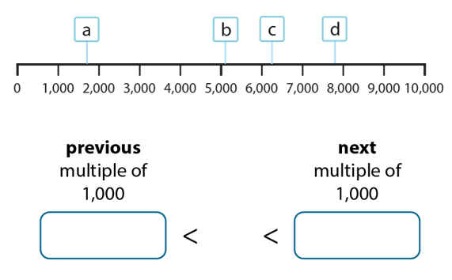

4)

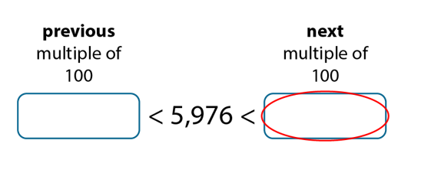

2)

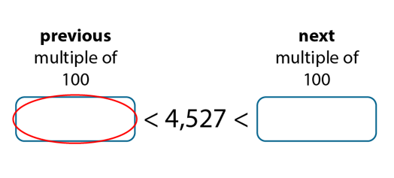

1)

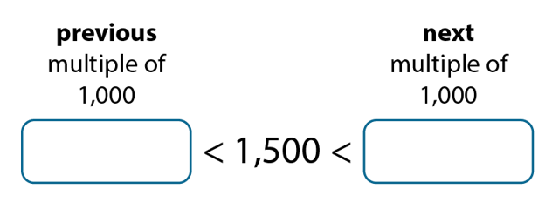

1. 1000 – 2000
2. 5000 – 6000
3. 6000 – 7000
4. 7000 – 8000

Teacher to mark

Jack is correct. He only needs to change the thousands column from 4 to 5

This is sometimes true. If the hundreds is 1-8 then you only change this column, however if you have a 9 in the hundreds you needs to cross into a new thousands and change this digit as well.

8)

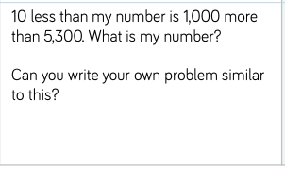

6)

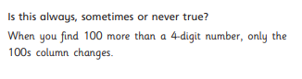

7)

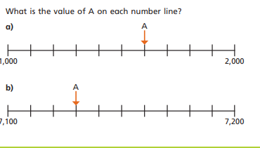

8)

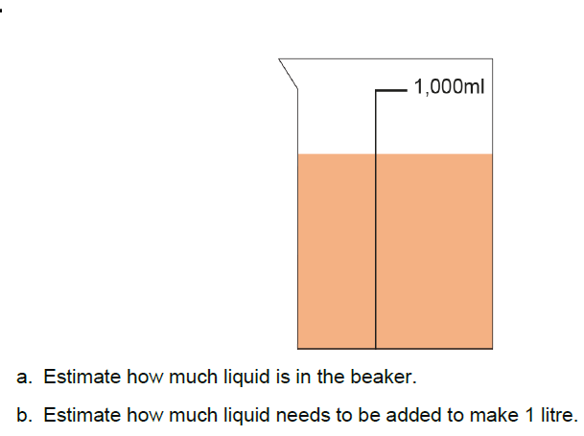

6310

1. Approximately 750-800ml
2. 250-200ml
3. 5050, 5425, 5690, 5820
4. Teacher to mark
5. 1600
6. 7400

8)

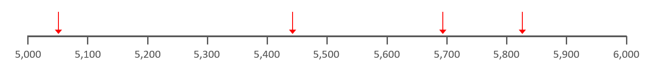

1. Can you estimate what numbers these arrows are pointing to?
2. Where do you think 5,260 would sit on the number line?